NOTES 8.6- Speciation and Darwin’s Finches
AIM: How did the finches of the Galapagos Islands contribute to Darwin’s theory?

Do Now: Read Paragraphs below and answer the checkpoints as you go.

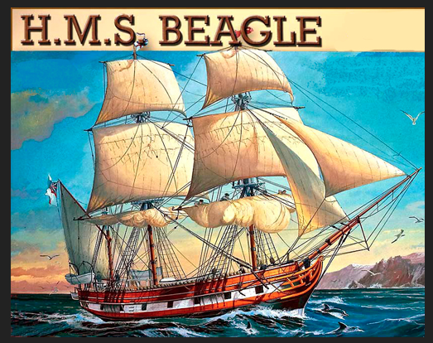
Though he was born over 200 years ago, Charles Darwin’s name is still famous for his groundbreaking theory of evolution through natural selection. The theory of natural selection proposes that species have evolved over time because organisms that are born with beneficial adaptations survive and reproduce to create more well-adapted organisms with that trait, while organisms that are not well adapted to their environment die and do not pass on their traits. As natural selection continues over time, the traits found in a population or species change. In other words, they evolve. But how did Darwin come up with this theory? What evidence did he see? To answer that question we must take a journey on the H.M.S. Beagle, the boat that Darwin set sail on to embark on his epic journey to the Galapagos- a set of islands that lay 1000km west of South America.

Check Point- Based on what you learned last week and the information in the passage, how do organisms evolve according to Darwin? Describe his theory.

The Galapagos Islands
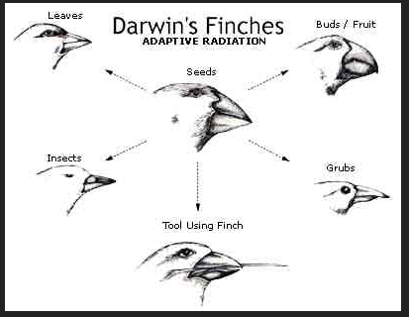
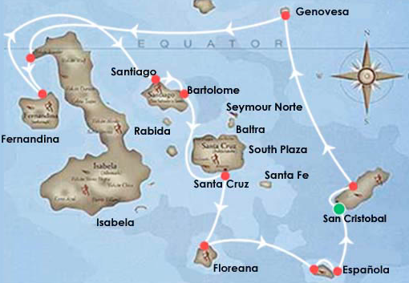
As Darwin sailed around the world he marveled at the extensive
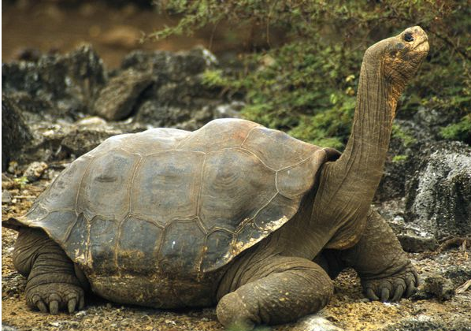
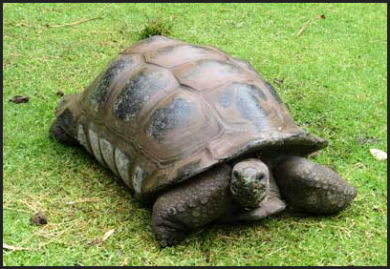
variation among organisms and the fact that each organism had traits that were perfectly suited for its environment and its job. However, the Galapagos Islands were of particular interest because these islands were not far apart but had very different climates. The smaller, southern islands, like Hood Island, were hot, dry, and had sparse (little) vegetation. Larger, northern islands, like Isabela island, had much greater rainfall and a large assortment of plants and animals. He also noticed that on each island there lived different varieties of organisms. The tortoises on hood island seemed to be a completely different species than those on Isabela island. The differences in these environments and organisms would be key to Darwin’s theory. As Darwin traveled among the islands he took particular interest in some birds which he had never before seen. He collected samples demonstrating their unique characteristics- in particular they all had distinct, differently shaped beaks. At first he thought they were all completely different birds- wrens, warblers, woodpeckers etc. However, as Darwin began to develop his theory of evolution he hypothesized that the various birds may have once been members of the same species. In other words, the 14 different species he found may have evolved from one common ancestor- a finch that flew over from South America. As such, Darwin devised a theory to explain this speciation- the process of creating new species, in terms of natural selection.
Tortoise Tortoise
on Isabela Island on Hood Island

Tortoise on Hood Island

Check point: According to what you have read thus far, how are Darwin’s finches an example of speciation?

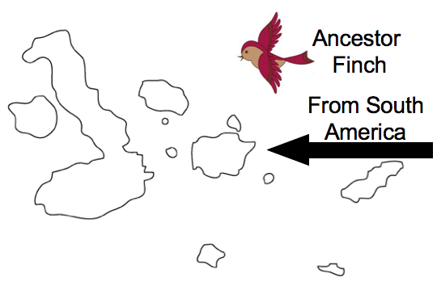
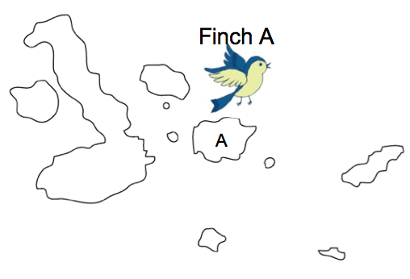
According to Darwin’s theory, many years ago a small group of finches may have been blown by a storm or gotten lost over sea and flew from South America to an island in the Galapagos. However, there is no longer any forms of the South American finches in the Galapagos because natural selection occurred. The South American finches were not perfectly adapted to the island environment when they arrived. However, there was likely some variation in the population, as they were a sexually reproducing population, that allowed them to survive. In other words, some of the finches may have had better adaptations than others. For instance, in South America the finches may have required slender beaks to catch worms, but on the island they required thicker beaks to crack open seeds. Thus, of the birds that arrived, those with the thicker beaks survived the best and reproduced. With time, speciation occurred. Natural selection continued until the population of finches evolved so much that they were considered a whole new species- Species A.

Check point: which of the following best explains how Finch A evolved from the South American finch?
(1) The new environment caused a mutation in the finches
(2) Variation among the population allowed some finches to survive while others died
(3) All of the South American finches adapted to their new environment and learned to eat new foods
(4) The South American finch went extinct in the Galapagos due to a harmful mutation.

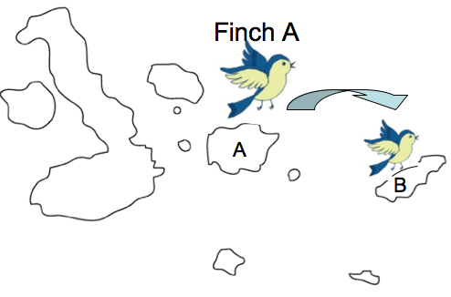
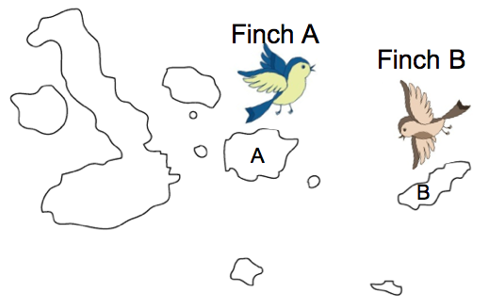
According to Darwin, eventually a small group of the Finch A population may have traveled to a nearby island (Island B) which had a slightly different climate and different food sources. For instance, the seeds may have been larger and more difficult to open. Though Finch A’s are adapted to eat seeds, they might have struggled to survive and subsisted on only the smallest of the available seeds on Island B. However, when a finch is born with a new variation- a considerably larger beak- natural selection may then occur until this entire population has large beaks. At this point, the population of finches would be considered a new species- Species B, meaning that speciation had occurred again.
Check point- The text says that one day a bird is born with a larger beak than the rest of the population. How is this possible?

Describe how species A evolved into Species B according to Natural Selection

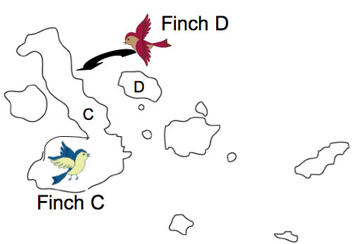
As finches continued to travel to the different islands natural selection and evolution continued to occur until there was a different species of finch on each island. But how can Darwin’s theory account for the fact that there are currently several different species of birds living on each island? Some of the larger islands have up to 7 different finches on them, each with its own distinct beak and niche. How did that happen?
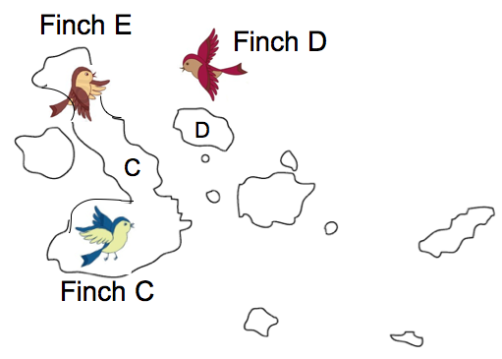
The concept of competition is crucial to Darwin’s answer. Darwin hypothesized that at times, groups of finches might fly to an island that already contains a different species of finch, which is well adapted to the island. Thus the finches would have to compete for food and inevitably some would die. For example, a group of finches (finches C) had medium sized beaks to eat the medium-sized seeds on island C. Another group (finches D) flies over from island D, and they have on average smaller beaks because they were adapted to the small seeds on island D. In the finch D population, those with the more medium-sized beaks will have to compete with the finch C population for food, and are more likely to starve. However the portion of the finch D population with smaller beaks might be able to find a different food source that no other finches eat- like small insects. In this case, the smaller beaked finch D’s are more fit because they do not have to compete with finch C. Natural selection will occur and eventually the finches that came from island D will no longer resemble the finch D population- this smaller-beaked variety will be considered its own species- Finch E.

Check point- Describe the role of competition in the natural selection and evolution of the finch population.

CLASSWORK 8.6- Speciation and Darwin’s Finches
Directions: Answer each question to the best of your ability. Ask if you have questions.
Use the diagram below to answer questions 1-5

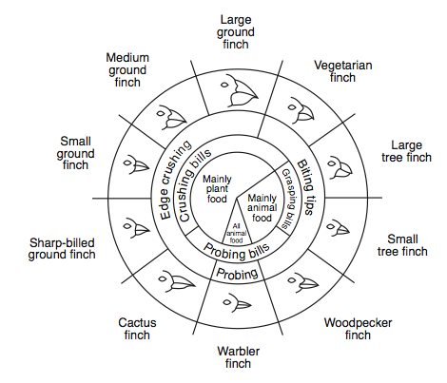
1. The only finch that is completely carnivorous has a beak adapted for
(1) probing, only (2) probing and edge crushing (3) probing and biting (4) biting and edge crushing

2. Which two finches would compete the least for food?
(1) small ground finch and large ground finch (2) large ground finch and sharp-billed ground finch
(3) small tree finch and medium ground finch (4) vegetarian finch and small ground finch

3. Identify one bird that would most likely compete for food with the large tree finch. Support your answer. [1]
__________________________________________________________________________________________ __________________________________________________________________________________________

4. Which factor most directly influenced the evolution of the diverse types of beaks of these finches?
(1) predation by humans (2) available food sources (3) oceanic storms (4) lack of available niches

5. Small ground finches and medium ground finches live on an island with abundant plant and animal food. Predict how the small ground finch and the medium ground finch would be affected if warbler finches migrated to the island where these finches live. Support your answer. [1]
____________________________________________________________________________________________________________________________________________________________________________________________
6. Researchers discovered four different species of finches on one of the Galapagos Islands. DNA analysis showed that these four species, shown in the illustration below, are closely related even though they vary in beak shape and size. It is thought that they share a common ancestor.
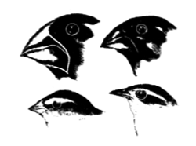
Which factor most likely influenced these differences in beak size and shape?
(1) Birds with poorly adapted beaks changed their beaks to get food.
(2) Birds with yellow beaks were able to hide from predators.
(3) Birds with successful beak adaptations obtained food and survived to have offspring.
(4) Birds with large, sharp beaks become dominant.

One species of bird found in the Galapagos Islands is the medium ground finch. It is easier for most of the medium ground finches to pick up and crack open smaller seeds rather than larger seeds. When food is scarce, some of the birds have been observed eating larger seeds.

7. Describe one change in beak characteristics that would most likely occur in the medium ground finch population after many generations when an environmental change results in a permanent shortage of small seeds. [1]
____________________________________________________________________________________________ ____________________________________________________________________________________________

8. Studies of the finches of the Galapagos Islands have shown that
(1) DNA will change to produce structures needed by birds to survive intense competition
(2) a bird’s beak changes annually in response to the type of food that is most abundant each year
(3) natural selection occurs when there are scarce resources and intense competition
(4) the beak of a finch will change if the environment of the bird remains stable

9. The diagram below shows four species of birds that evolved from an ancestral species that had a small, pointed beak. Today, all four species inhabit the same island.
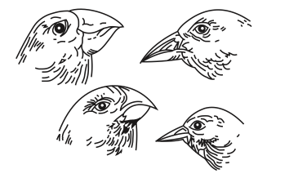
Which statement best explains the variation in the beaks of these four species?
(1) Overtime, an abundance of seeds for food led to increased similarities between the species.
(2) Over time, an abundance of seeds for food led to increased differences between the species.
(3) Competition for limited food resources led to selection for similar traits.
(4) Competition for limited food resources led to selection for different traits.

Evolutionary changes have been observed in beak size in a population of medium ground finches in the Galapagos Islands. Given a choice of small and large seeds, the medium ground finch eats mostly small seeds, which are easier to crush. However, during dry years, all seeds are in short supply. Small seeds are quickly consumed, so the birds are left with a diet of large seeds. Studies have shown that this change in diet may be related to an increase in the average size of the beak of the medium ground finch.

1. The most likely explanation for the increase in average beak size of the medium ground finch is that the
(1) trait is inherited and birds with larger beaks have greater reproductive success
(2) birds acquired larger beaks due to the added exercise of feeding on large seeds
(3) birds interbred with a larger-beaked species and passed on the trait
(4) lack of small seeds caused a mutation which resulted in a larger beak

2. In exceptionally dry years, what most likely happens in a population of medium ground finches?
(1) There is increased cooperation between the birds.
(2) Birds with large beaks prey on birds with small beaks.
(3)The finches develop parasitic relationships with mammals.
(4) There is increased competition for a limited number of small seeds.
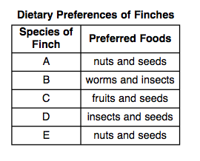
Base your answers to question 6 on the data table below and on your knowledge of biology.

6. Which two species would most likely be able to live in the same habitat without competing with each other for food?
(1) A and C
(2) B and C
(3) B and D
(4) C and E

