**Name: Date: Period:**

**Fossils Homework**



1. Place the layers in Column 1 in order from oldest to youngest.
2. What kind of fossils occurred in layer F?
3. What “fossils clues” in layers A and B indicate the kind of environment that existed when these rock layers were formed? How did the environment change in layer D?
4. Which layer is the oldest in Column 2? How do you know?
5. Which of the layers formed most recently in Column 2? How do you know?

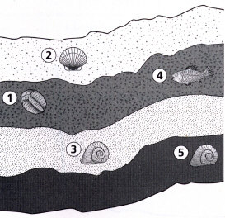

*Use the diagram to the right to answer question 6-8.*

6. Place the rock layers in order from youngest to oldest.

7. What type of animal do you think organism #1 is? Why?

8. Describe how the fossil layers could have formed.

1. How is sedimentary rock formed?

2. List 3 things that fossils can tell us.

*Use the diagram of sedimentary rock layers to answer questions 3-5 below.*

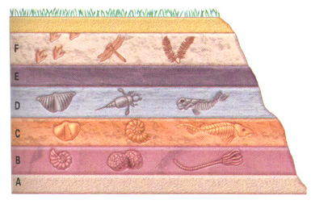

1. What type of major event do you think occurred after layers D and E? Explain.
2. What inferences can you make of the life forms that existed at the time that A was formed?

1. If radiometric dating identifies the rock layer C as 425 million years old:
   1. What can you infer about the age of the fossils in layer C? Explain.
   2. What about the age of the fossils in letter D?
   3. What about the age of the fossils in letter B?