Name: _____________________________________ Section: _____ 11/28/2011
Introduction to the Law of Conservation of Mass Homework (SPI.9.11)
Part I: Defining the Law of Conservation of Mass
- What is mass?

- What scientific tool is used to measure mass?

- What is the Law of Conservation of Mass?

- The word conserve means “to keep up, to maintain, to preserve.” Based on this definition, why do you think that this law is referred to as the Law of Conservation of Mass?

- Can any reaction break the Law of Conservation of Mass? Are you positive?
Part II: Applying the Law of Conservation of Mass to Chemical Reactions
Using the diagram below, answer questions 1-5.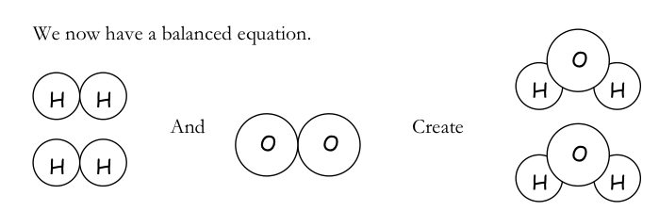
- Write a chemical equation to express the chemical reaction above.

- What are the reactants in this equation?
- What are the products in this equation?
- What evidence from the diagram (hint: think about the atoms!) do you have that this chemical reaction follows the law of conservation of mass?

In the following chemical equations, fill in the mass of the missing reactant or product according to the Law of Conservation of Mass.
- 3 grams reactant X + 8 grams reactant Y → ______ grams product Z
- 7 grams reactant E + ____ grams reactant F → 9 grams product G + 10 grams product H
- ____ grams reactant U + 3 grams reactant V → 12 grams product W
- 10 grams reactant Q + _____ grams reactant R → 100 grams product S + 10 grams product T
- 13 grams reactant G → _____ grams product H + 8 grams product J
- 70 grams of reactant produces ______ grams of product
Fill in the blank with the correct number; also underline the reactants and circle the products:
1. 24 g of magnesium reacts with 38 g of fluorine to produce _____ g magnesium fluoride.
2. 65 g copper reacts with _____ g oxygen to produce 81 g copper (I) oxide.
3. 80 g of strontium reacts with 160 g bromine to produce _____ g strontium bromide.
4. ____ g iron reacts with 71 g chlorine to produce 129 g of iron (II) chloride.
5. 100 g of barium reacts with ______ g iodine to produce 390 g barium iodide.
6. _____ g hydrogen reacts with 32 g of oxygen to produce 34 g of hydrogen peroxide

Answer the following questions:
1. When you heat liquid metal mercury in air it combines with oxygen and turns into an orange solid called mercury (II) oxide.
- What type of change is occurring in the description above?

- What evidence is there to support your claim?

- If you heat 2.53 grams of mercury and produce 2.73 grams of mercury (II) oxide, how much oxygen reacted with the mercury?

2. 15 grams of Hydrogen and 7.5 grams of Oxygen were placed in a beaker. An explosion happened inside the beaker that produced water. The beaker was never opened. How many grams of water were produced?

3. What is the difference between the mass of an ice cube and the mass of the water it melts into?

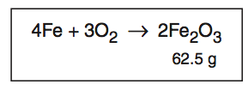
Use the chemical equation above to answer questions 4-6.
4. Fill in the table below with the appropriate missing information.
Substance | Reactant or Product? | Element or Compound?
Fe
O₂
Fe₂O₃
5. What was formed between iron (Fe) and oxygen (O) to create a new substance (Fe₂O₃)?
6. If 43.7 g of iron is completely used in the reaction above, how many grams of oxygen are involved in the reaction?

