Name: Date: Period:
Objective: SWBAT demonstrate the Law of Conservation of Mass through a chemical reaction between baking soda and vinegar.
SWBAT collect and analyze data, communicate their findings through a lab report.

Law of Conservation of Mass Lab

Introduction:
The “Law of Conservation of Mass” states that when matter goes through a physical or chemical change, the amount of matter stays the same before and after the changes occur. In other words, matter cannot be created or destroyed. In today’s lab, we are going to see an example of how this happens in real life even though it may seem that the law has been broken. Make sure that you are thinking critically by analyzing this real world situation and identifying its connection to science.

Lab Prework:
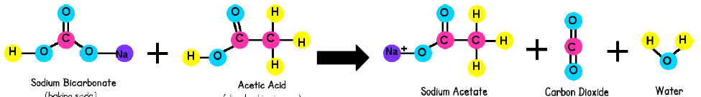
1. ) What does the Law of Conservation of Mass state? ______________________________________________________________ ___________________________________________________________________________________________________________________________
Chemical Reaction:
NaHCO₃ + CH₃COOH NaC₂H₃O₂ + + CO₂ + H₂O
(baking soda) + (Vinegar )
2.) List the Reactants of this chemical reaction: _______________________________________________________________________
3.) List the Products of this chemical reaction: ________________________________________________________________________
4. ) Count the number of elements on each side of the chemical equation and write the total below:
Reactants: H ______ Na _______ C________ O _______
Products: H ______ Na _______ C________ O _______
5.) Is this a balanced equation? Explain WHY!

Question
(What are we learning today?)
Hypothesis
(If, then, because)
IV  (What are we changing?) |  | DV  (What are we measuring?)
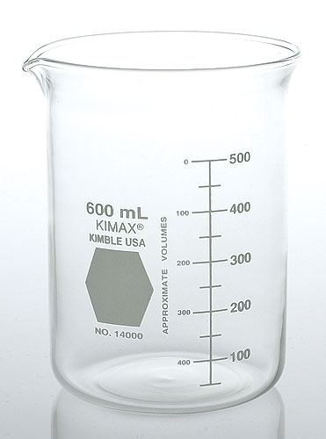
Materials: List the materials that you see on your lab bench. Make sure to use their scientific names when possible.
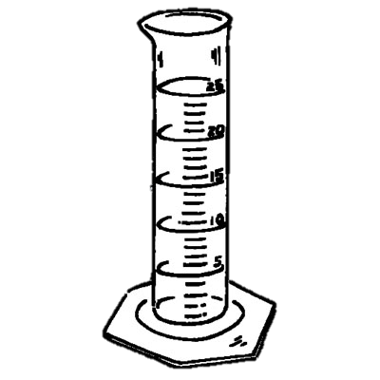
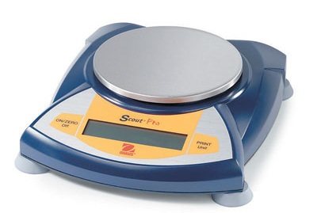

1.) _________________________________ 2.) _________________________________ 3.) _________________________________

4.) __________________________________ 5.) _________________________________ 6.) ________________________________

7.) _________________________________ 8.) _________________________________

Procedures: You must follow each of these steps!

- Measure __________ mL of vinegar using a graduated cylinder.
- Pour the __________mL of vinegar from the graduated cylinder into plastic bottle.
- Use the spoon to carefully put 1 spoon of baking soda into the opening of the balloon.
- Press TARE on the electronic balance scale.
- Take the mass of the bottle with the vinegar AND the mass the balloon w/baking soda TOGETHER using the scale. Record the mass in the data table as the INITIAL MASS.
- Remove the bottle with vinegar and the balloon with baking soda from the balance scale.
- Fit the balloon onto the opening of the bottle making sure NO baking soda spills into the flask.
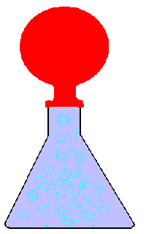
- Once the balloon is on the bottle, lift the balloon so the baking soda mixes with the vinegar (see image below). Write your observations on your data sheet.
- Once the reaction stops, hit tare on your balance scale and take your ENTIRE setup and place it on the digital scale. Record the mass in the data table as the FINAL MASS.
- Remove the bottle from the scale. Remove the balloon from the bottle and allow it to deflate. Place the bottle and deflated balloon on the scale and record the mass.
- Clean-up your station and begin answering the conclusion section.

Data: Record any measurements or observations you have made.

Initial Mass  (Flask + Balloon = Total) | Final Mass  (What is the mass after the reaction takes place?) | Mass after balloon is deflated
Observations of Reaction: What do you see, hear, smell, feel?

Analysis: All answers should be written in a complete sentence.

- What evidence was there that a chemical reaction occurred? What were the 4 outcomes of this chemical reaction?

- What were the reactants and products of this chemical equation?

- How did the final (products) mass of the system compare with the initial (reactants) mass? How did your result support or violated the Law of Conservation of Mass? (Hint* : Was any matter created or destroyed?)

- After you let the air out of the balloon, what happened to the total mass? Increase, decrease, stay the same? Explain why you think the change occurred.

- Write your own definition of the law of the conservation of mass.

- What are some ways in which this experiment could be improved? How else could you have tested the law of conservation of matter for this reaction? What other experimental designs could you have used? Write a different procedure that can be used to test this law.

Conclusion: Describe what you learned from this experiment. Make sure to use 4-5 complete sentences.
In your conclusion include:
    - Restate the LCM.
    - Rewrite your hypothesis.
    - Explain the evidence that tell you a chemical reaction has occurred.
    - Explain how the experiment did or did not demonstrate the LCM.
    - Use your data to support your answer.

___________________________________________________________________________________________________________________________________________________________________________________________________________________________________________________________________________________________________________________________________________________________________________________________________________________________________________________________________________________________________________________________________________________________________________________________________________________________________________________________________________
__________________________________________________________________________________________________________________________________________________________________________________________
__________________________________________________________________________________________________________________________________________________________________________________________
__________________________________________________________________________________________________________________________________________________________________________________________
__________________________________________________________________________________________________________________________________________________________________________________________
__________________________________________________________________________________________________________________________________________________________________________________________
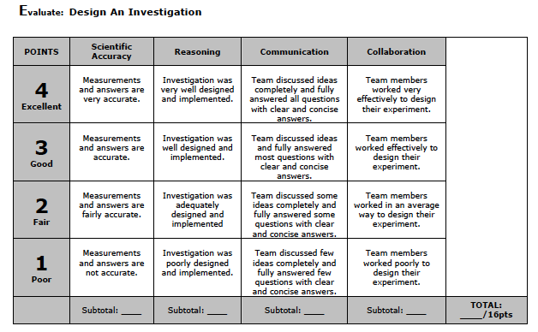
Conclusion:
 | Points | Points Earned
Restate the LCM. | 1
Rewrite your hypothesis. | 2
Explain the evidence that tell you a chemical reaction has occurred. | 3
Explain how the experiment did or did not demonstrate the LCM. | 4
Use your data to support your answer. | 4
 | Total: | _______/14

