LCM Small group stations:

Station 1: Balancing Equations : In partners at the computers
Objective: SWBAT determine whether a chemical equation is balanced or not. They will manipulate the coefficients to make sure the chemical equation demonstrates the LCM by having the same atoms on the reactants and products (Balanced Equation).

Noise level: Whispering (library voices)
Engagement level: Partner work.

Directions:
- Open up Firefox window.
- Google: PHET Balancing Equations.
- Click “Run Now!”
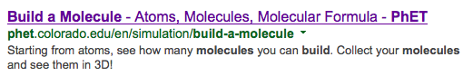

- Click “balance scales” and “bar charts” at the bottom and determine which tool you would like to use.
- Answer the questions as you explore the simulations.
- Once you are done with the first 3 introduction questions, move on to the balancing game.

Station 2: Creating Molecules station @ Smart Board
Objective: SWBAT work together to practice counting atoms on either side of the chemical reaction by building molecules.

Noise Level: WHISPERING (Library voices)
Engagement Level: Group Effort

Directions:
- Open up Firefox window.
- Google: PHET Build a molecule.
- Click 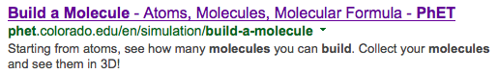
- Click “Run Now!”

**** Please take turns building the different molecules *****
- Start by clicking the “Make Molecule” tab on the top. Click and drag the atoms to the center to create molecules. Once you have created the molecule, drag them to the correct chemical symbol.
- When you have finished making those molecules, click the blue “Collect Multiple” tab on the top. Create the molecules and place them in the correct chemical symbol.

Station 3: Writing Station
Objective: SWBAT use evidence to explain the Law of Conservation of Mass.

Noise Level: Silent. Engagement Level: Independent Work

1.) Draw the atoms of a chemical reaction that demonstrate the law of conservation of mass.

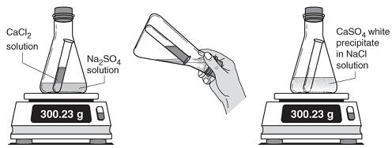

2.) Ms. Kim conducts an experiment that demonstrates the Law of Conservation of Mass. Ms. Kim’s experiment is pictured above. Ms. Kim’s assignment is to write a conclusion about her experiment.

Conclusion: Describe what you learned from this experiment. Make sure to use 4-5 complete sentences.
In your conclusion include:
    - Restate the LCM. (1 pts)
    - Explain the evidence that tell you a chemical reaction has occurred. (2pts)
    - Explain how the experiment did or did not demonstrate the LCM. (4 pts)
    - Use your data to support your answer. (3pts)
Total Points Possible: 10

Ms. Kim’s Conclusion:
The Law of Conservation of Mass is a law that can’t be broken. This is a chemical reaction because a new substance was made. The experiment demonstrates the Law of conservation of mass because nothing was created or destroyed.

How many points did Ms. Kim earn? ______ of 10
What could she do to make her conclusion better?

Ms. Kim rewrote her conclusion!
The Law of Conservation of Mass states that matter cannot be created or destroyed. That means that the mass of the reactant equals the mass of the products. In this experiment, a chemical reaction occurred between the reactants CaCl₂ and Na₂SO₄ and made the product CaSO₄ and NaCl. This experiment demonstrate the Law of Conservation of Mass because even though a new substance was created, matter was not created nor destroyed.

How many points did Ms. Kim earn? _______ of 10.
How can she improve her answer?

Help Ms. Kim write the BEST CONCLUSION!
Use the directions and point system that we used to evaluate Ms. Kim’s conclusion to write your own conclusion that would earn ALL 10 POINTS!

 | Day 1 | Day 2
Table 1 + 4 | Station 1 | 2 + 3
Table 2 + 5 | Station 2 | 3+1
Table 3 + 6 | Station 3 | 2 + 3

Finished early? Work on your study guide! Make sure that you get the correct answers from the website.

